Environment Setup

Create a Nutrition API account

|  |  |
| --- | --- |
| Team ID | PNT2022TMID43211 |
| Project Name | Nutrition Assistant Application |

Swetha R:

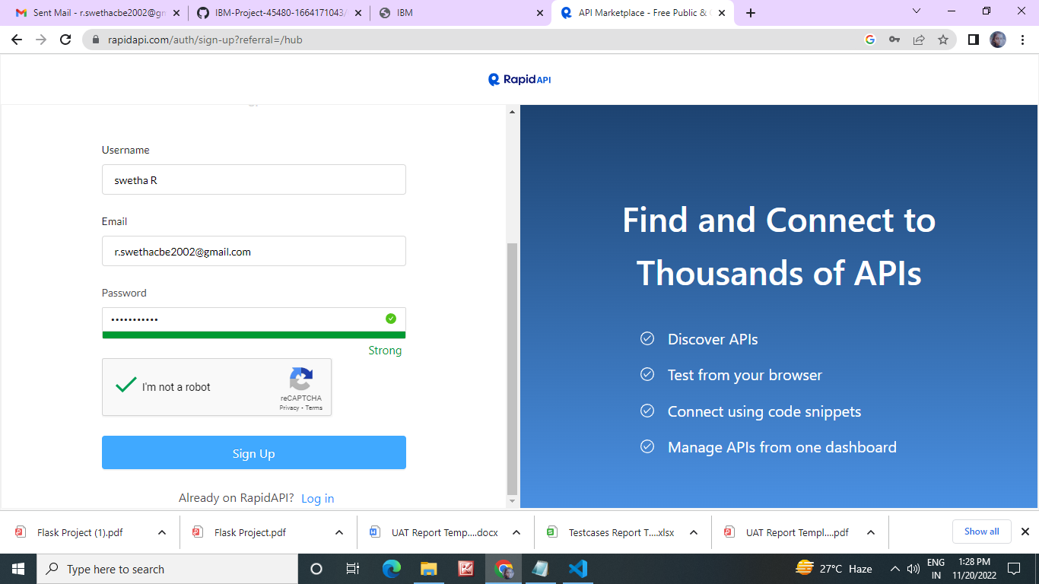

Swetha s:

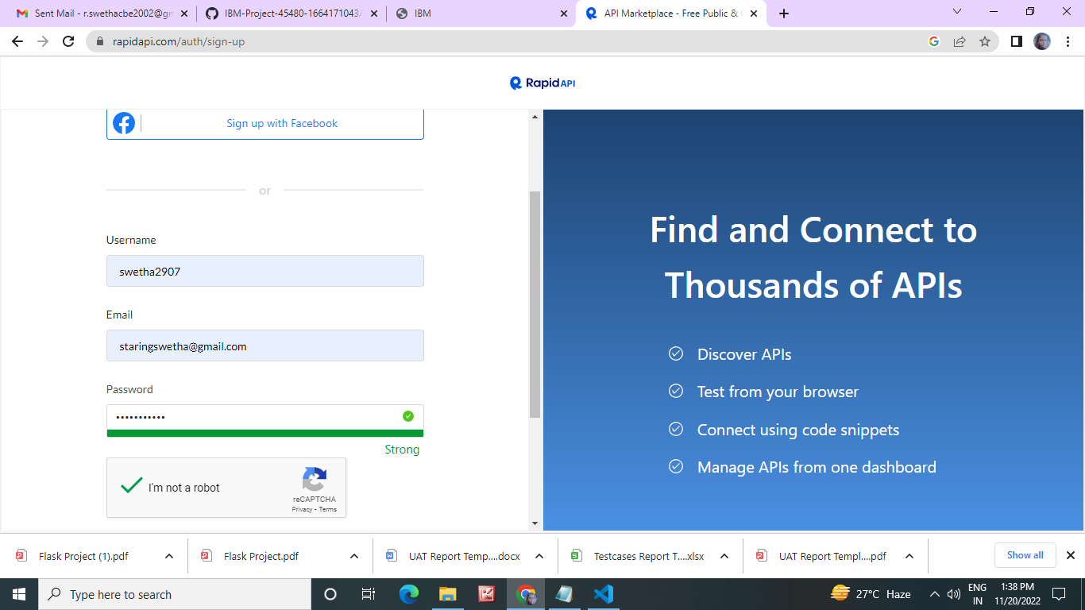

Susmitha s:

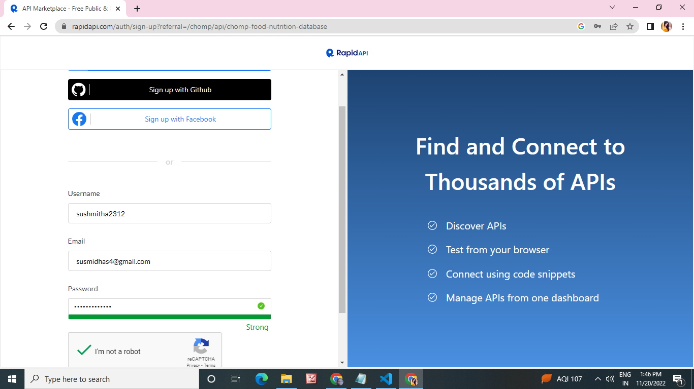

Snehalatha J B :

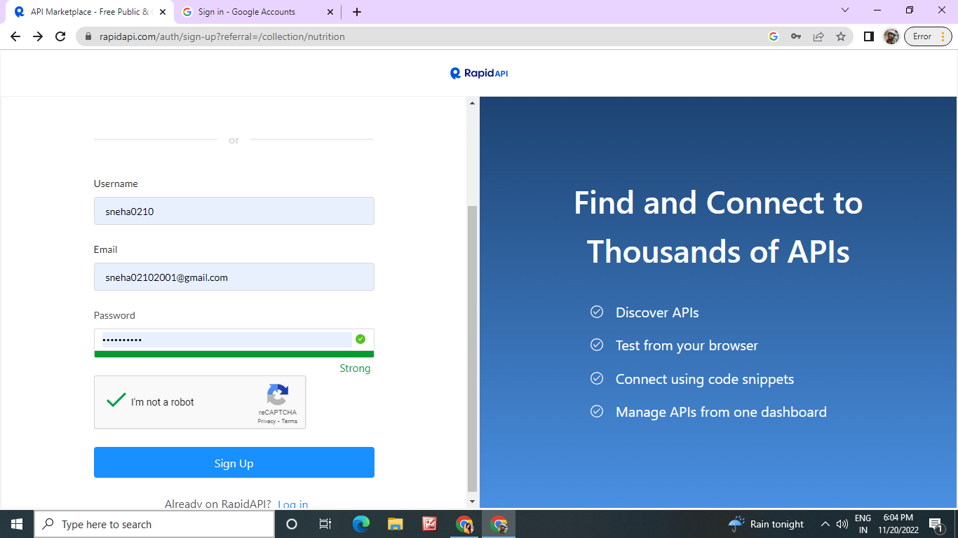

**Terminal :**

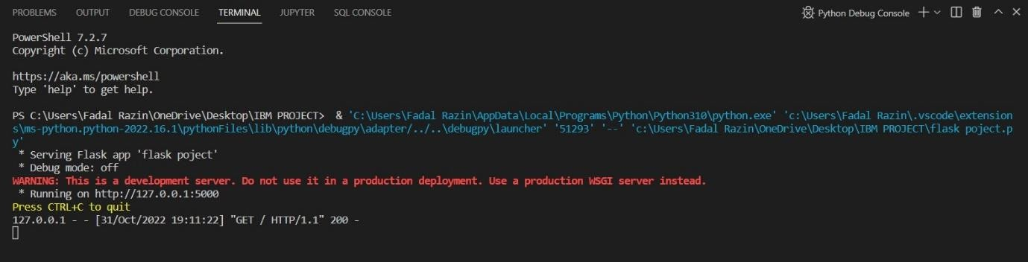

HOME page:

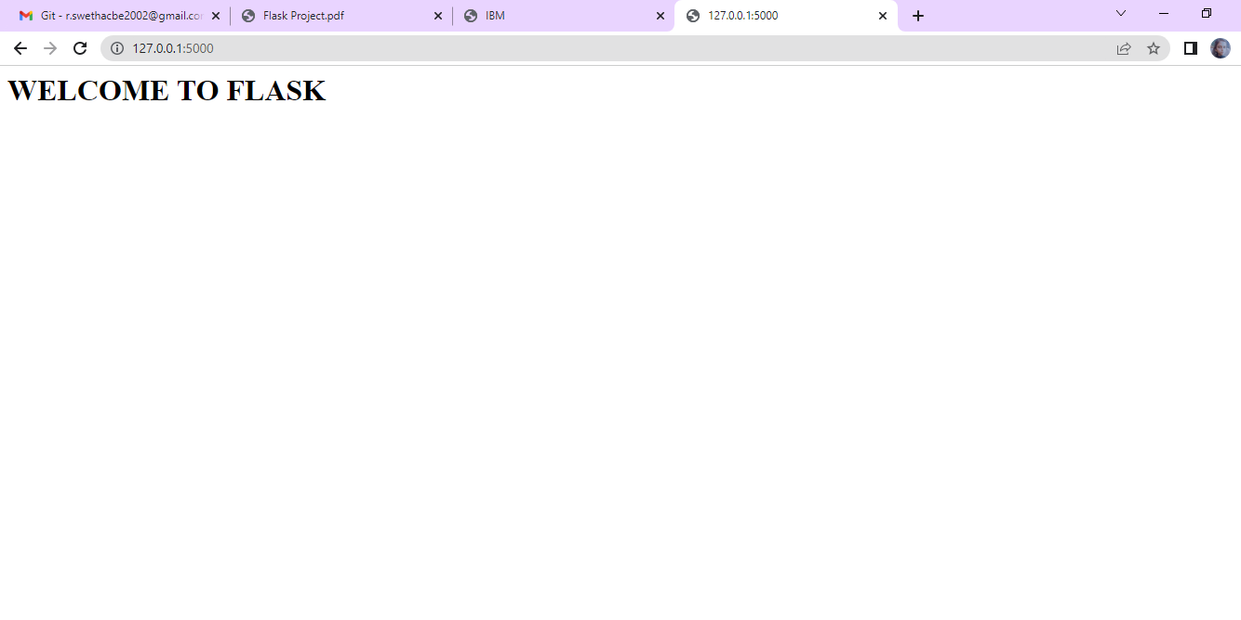

**ABOUT page:**

